**Cloud Computing**

**UE19CS352**

**6th Semester, Academic Year 2021-22**

Week #: 3 - Docker

Date: 26/2/2022

|  |  |  |
| --- | --- | --- |
| Name :  SUMUKH RAJU BHAT | SRN :  PES1UG19CS519 | Section :  H |

**1a.jpg:** Screenshot of running docker hello-world.

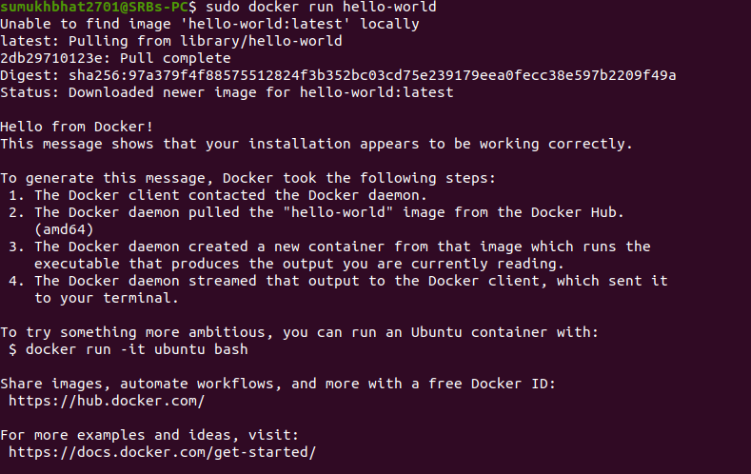

**2a.jpg:** Screenshot of C Program successfully run inside the container.

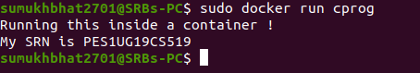

**2b.jpg:** Screenshot of the image pushed to Dockerhub.

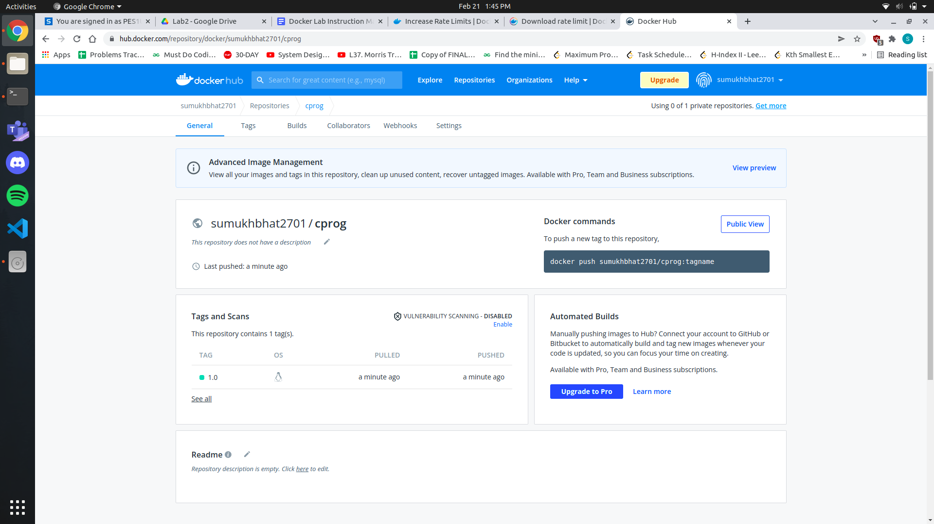

**3a.jpg:** Sample.html showing the web page on the browser.

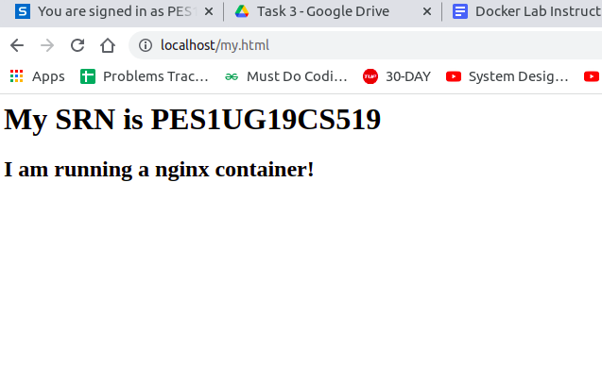

**3b.jpg:** Screenshot of docker container running nginx

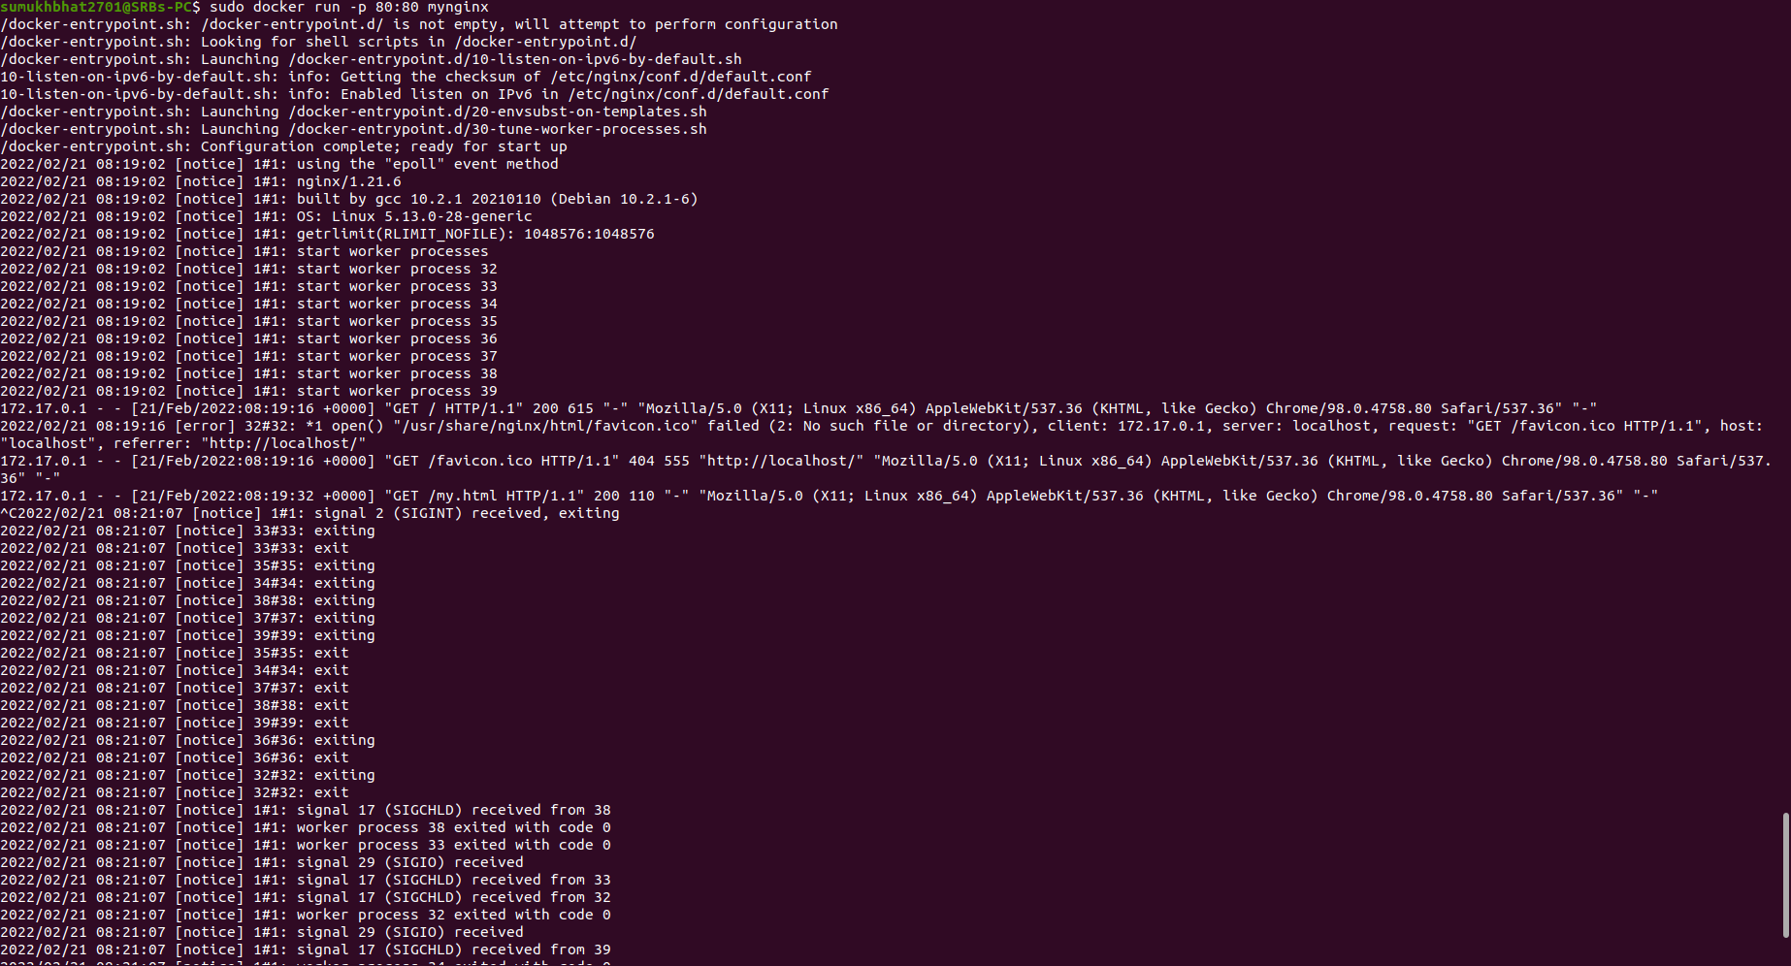

**3c.jpg:** Screenshot of python application successfully writing and reading from the MongoDB database



**3d.jpg:** Screenshot showing mongodb being run within the network(docker command has to be clearly highlighted)



**3e.jpg** Screenshot showing python file being run within the network and successfully writing and reading from MongoDB(docker command has to be clearly highlighted)



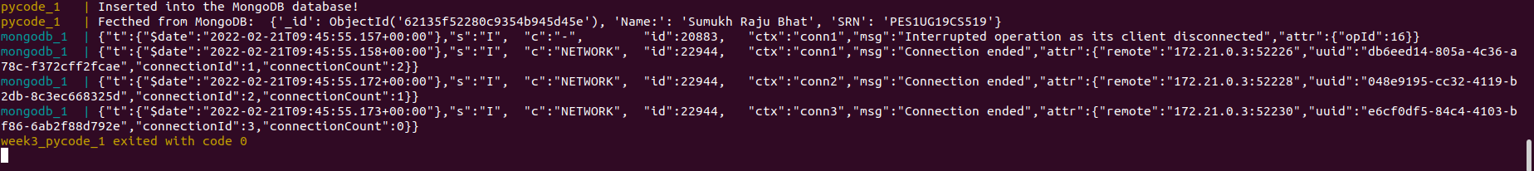

**4a.jpg:** Screenshot of python-mongodb application running as a docker-compose application(logs of the application)

Output:

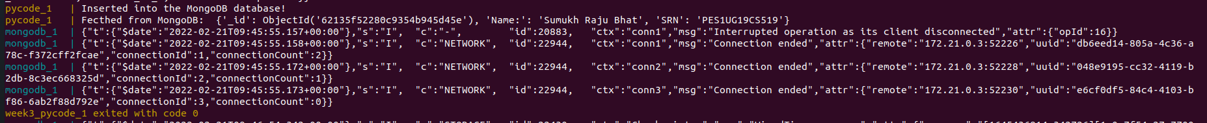

Logs:

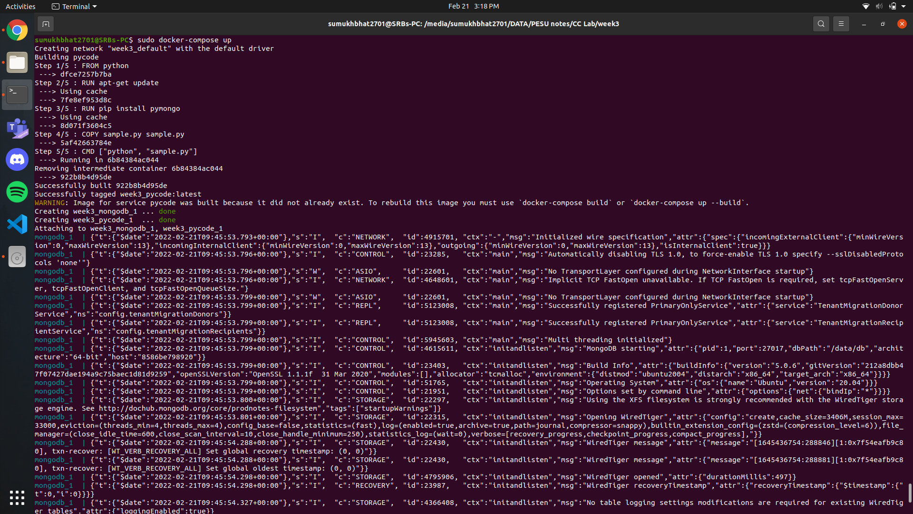

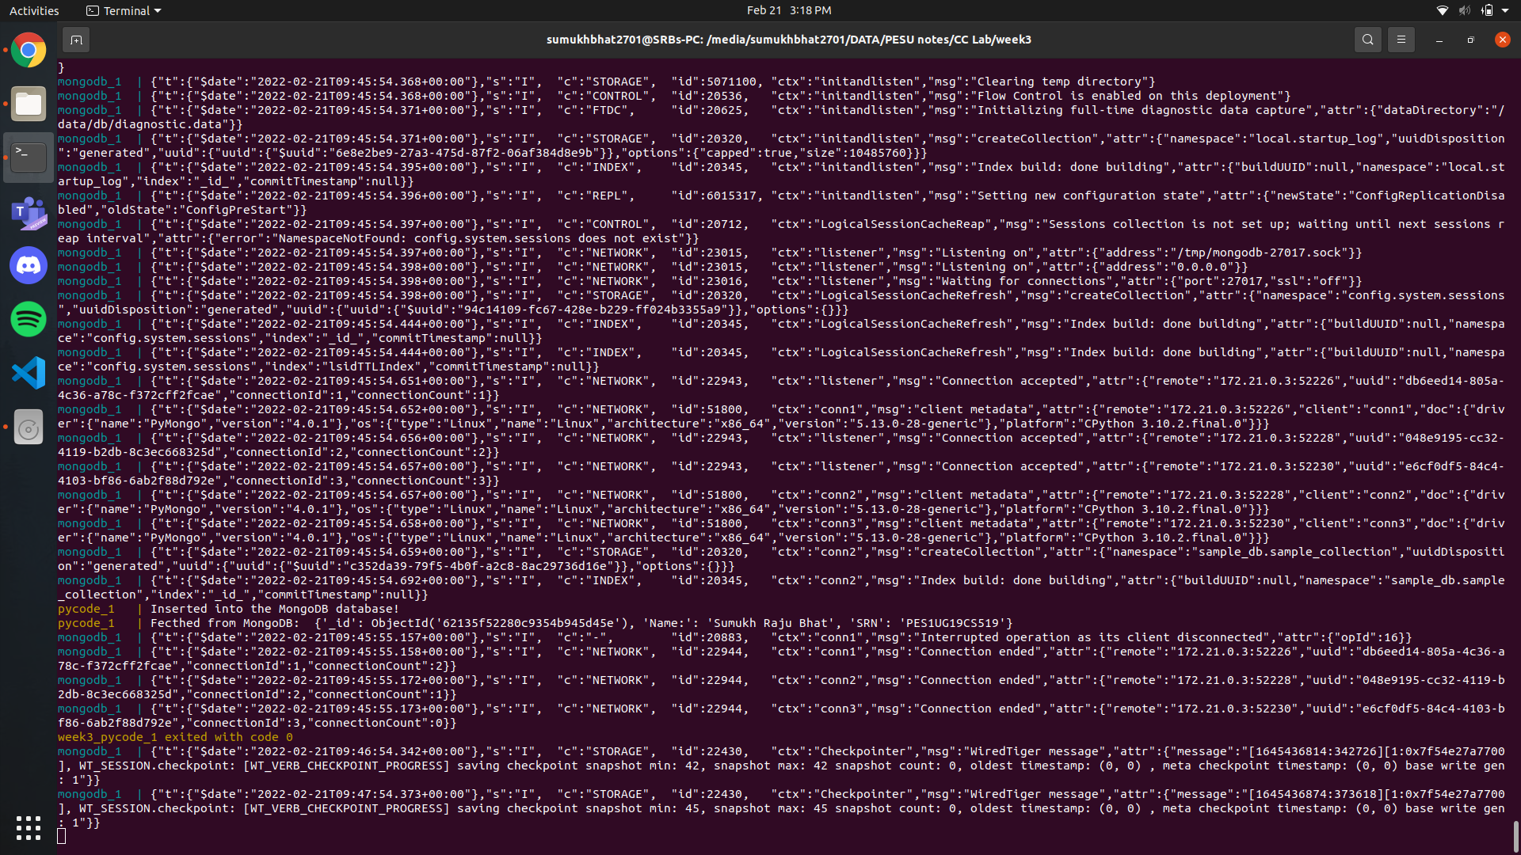

**4b.jpg:** Screenshot of 3 python application writes and reads from MongoDB after scaling the python application.

Screenshot from 2022-02-21 15-20-39 (copy)



